Increment 2 Report

**Plan Your Shopping**

**Project Group 18**

Vikas Kondapalli (39)

Swatvik Gunamaneni (27)

Gopi Kirshna Bodapati (8)

**Introduction**

Our project is a website which allows its users to plan their shopping well in advance before they actually go the stores. The website accepts the input from the user where he specifies the product he is looking for. Then the system displays a list of all the stores in the close proximity to the user with the distance from the user and the price of the product at each store. The user then chooses the product from the store of his choice considering the price and also the distance from his place. He can add this choice to his cart and start all over again searching for a new product. He continues in this fashion until he finds all the products he needs to shop for. Finally on completing his search he has all the items added to his cart. The cart gives him the total amount he is supposed to spend in buying these items and also segregates the list based on the store each item has to be brought from.

The major progress we have made from the first increment to this increment is our move towards implementation after the discussion and planning phases. For this phase we have come up with login and registration pages where the user on his first visit gets himself registered with the website.Then he tries to log in. We have connected the login and register pages to the database MongoDB using the Data API offered by MongoLab. So initially when the user registers himself, his details get stored in the Database and when he tries to log into the website his credentials are validated against the ones already stored in the database. After the user successfully logs into his account he is directed to his dashboard, which is the actual workplace where he performs search and operations and gets the results displayed. In this phase we are accepting inputs from the user like his State and City and then we display the list of all stores close to him. He then chooses a store and searches for the price of an item he needs at that store and then has a list of the same item from different producers with their prices.

**Features**

When the user visits the website he has two options. If he is a first time visitor he can move to the registration page in order to sign up. In the registration page he can give all the details he is asked for and create his account. All the details he gives are stored in the MongoDb database and are used to validate him when he tries to log into his account in the future. He then can move to the log in page and access his account.

If the user already has an account he can simply give his username and password to log into his account. The username and password will be validated against the ones in the database which he gave while creating the account. After successfully validating these details with those in the database he gets directed to his dashboard. All the interactions with the database have been carried out using the Data API.

The dashboard is like the home page of the user’s account. Here the user chooses his state and city from a drop down box. For the current increment we have included only the cities in Missouri state and for the coming increment we will include all the other states and their cities.

On giving his choice of state and city the user now gets a list of all the stores in the city he chooses as a result. This is accomplished using the Supermarket API.

Now the user selects a store and enters the store id of this store and the item he is searching for. Then he gets a list of the same item from all available manufacturers available at that store with the price in each case. Even this service is enables using the Supermarket API.

In the next increment we will introduce speech input where the user can search for the products using voice inputs in addition to the existing text inputs from the drop down boxes.

**Import Existing services/API:**

**SuperMarketAPI:**

In this project (plan your shopping), the challenging part is to provide dynamic detail of product in store to user on daily basis. The main purpose is provides information about prices of item in store for this it necessary to retrieve data from store. To sever this, we have use super market API. Super market API is an open source API which present information about 9000 supermarket across USA includes Walmart, Costco etc. API allow user to search and retrieve item based on product name, item id, state zip code and store name.

Link on web: <http://supermarketapi.com/Default.aspx>

**Google Maps API:**

Other task in the project was to present the route direction to the store for this purpose we have use google maps API so, that it would be convenient to user to get item from the store in addition to this it provide number from the present location to stores. This help user to know which store is near which one is far. Google map API is open source API which display map based on the input provided by user. After selecting item from home page on click on direction button it direct to webpage where user is present with direction from current location to desired store. This will repeat for every selection of product from different stores.

Link for Google Maps API used in this project:

<https://maps.googleapis.com/maps/api/js?v=3.exp&sensor=true>

**MongoDB**

To data we have use MongoDB which is store data in document oriented manner,it also popularly called as “NOSQL” un it can like traditional table based relational Database it has a flexible schema. Some of feature it includes are document-oriented, Adhoc queries, indexing, replication, load balancing, File storage. It important feature is that having replica data which store data in different machine provides high availability. Each user has separate account to store data. User can store use collection which is similar to table in relational database. MongoDB is enriched with data API which are default in disable state it can be used to get data from database, collection and document. Every user has its own API key that can used to access the APIs.

Link for MongoDB Data API used in this project:

https://api.mongolab.com/api/1/databases/vikas2/collections/users?apiKey=HxPILPvmcIj3SyZBMlrPV38t7_BiBKUJ

**Detail Design of Services (using tools)**

**UML Diagrams:**

**Class Diagram**



In this class diagram customer, user, shopping system, cart, Registration are class.Here Customer is the super class of the user i.e for the normal user to become the customer of this application he has to register and store his details in database. Every user interact at least one registration class and detail of it store in Database. Customer then interacts with Shopping search system class to serach for the required stores and items. Shopping system class has websevice API which is a class based on information provided by user. Shopping class is relate to Map director to locate store.

**Sequence Diagram**

**For registration**



In this sequence diagram message are pass between actors. Customer present information about that is require for registration which is validates by registration page then store into database after storing detail returns successful message to customer.

**For Search and display service**



Customer login into system by provide information system then validate by comparing information registration provide by user. User in then navigate to searcher system where use is allow to select product and stores by using various API. After selection of item user is allow to add item into cart and show location of store in map.

**State Diagram**



In state Diagram user is direct to system after providing valid login detail, each component in system is represent by state and states are controlled by either by external or internal event such as on selecting item from store system display details later shows direction to store specified by user.

After the login system enters into input_taking state where it accepts search input. After the input is read it enters into Searching state. Then it enters into Display_details state and Render_directions state.

**System Architecture Diagram**

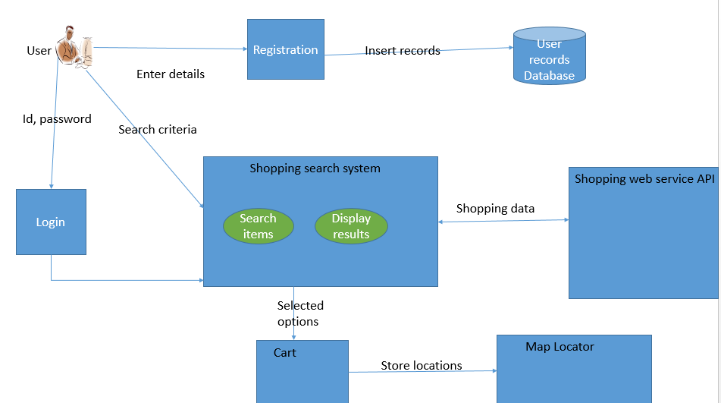

This system architectural overview where system is interacting with various API services to present information to user. New user access system by registrations mandatory information which is store in Database. Current user can use system through login to system to get desires data for example get prices of item then item is add into cart. Shopping search system has two processes search items and display results. Store location use map locator API is used to get detection to particular store.

**WireFrames and Mockups:**

**Wireframes:**

**Home page**



This is the home page where user need to provide valid information in order to access the service and for new user there will be redirect to registration page on clicking sign up button. Here we have use to two button sign in button user is sail to login page

**Registration Page**



New User has to register by providing some of the personal detail on clicking button “create account” information of the particular user stores in database. Here user first name is used as login id. Here use need to enter their email id or mobile number, first name, last name, password in order to registered into service.

**Login Page**



Login is stating page of service where use need to provide user id and password to get into service. Hyperlink will redirect to “forget password” where user can retrieve password store in database. On providing valid login id and password service will redirect to same page and passes invalid message to the user.

**Dashboard**



System allow user to selecting of item or product in dashboard page in additional to this user are allow to select store or supermarket on clicking to button user redirect to cart page. In this page user are allow to add or delete product from list. On clicking button “Get Detail” detail of item in select store is show in the list so that user can select item based on their budget plan.

**Cart Page**



In cart page user get information of product selected by individual it also including cost and store he/she need to get from. After user is navigate to map locator page. Here selected item are dynamically add to list along with detail of products. The button sort by cost allow user to get list in ascending order based on prices of item.

**Map Locator Page**



In this system provide location of store and distance from his/her current location. In this user is displayed with short distance from his/her current location to particular store so, user can save time which is prime motive of project.

**Mockups**

**Home page**

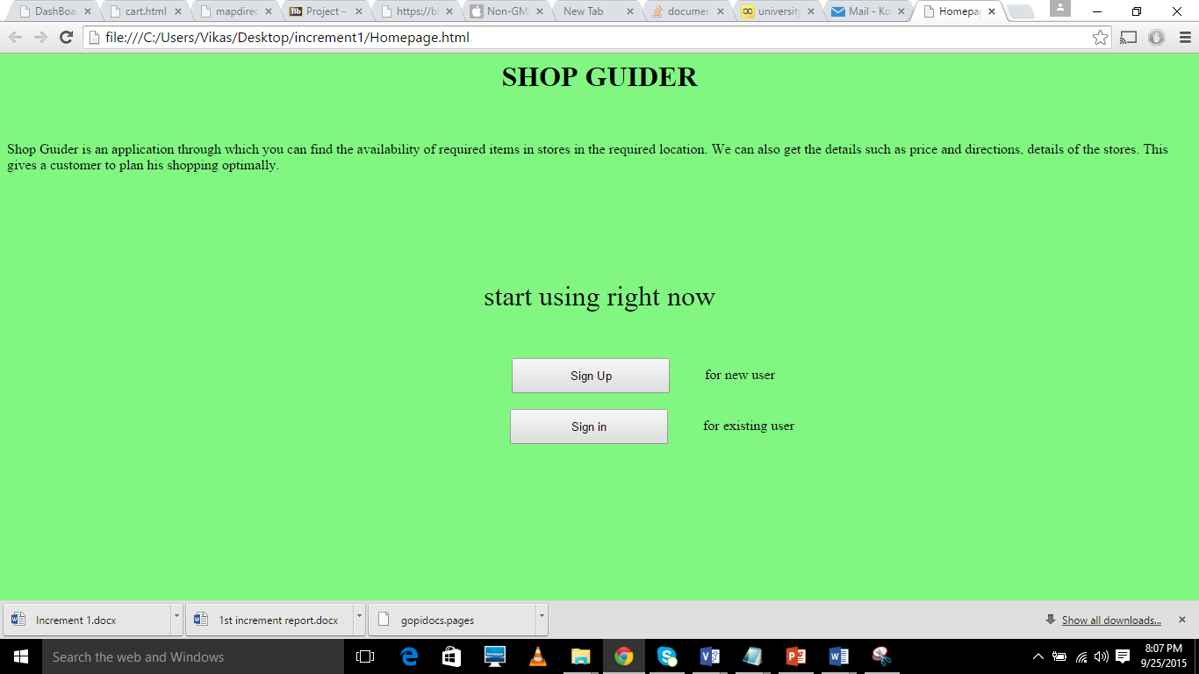

**Registration Page**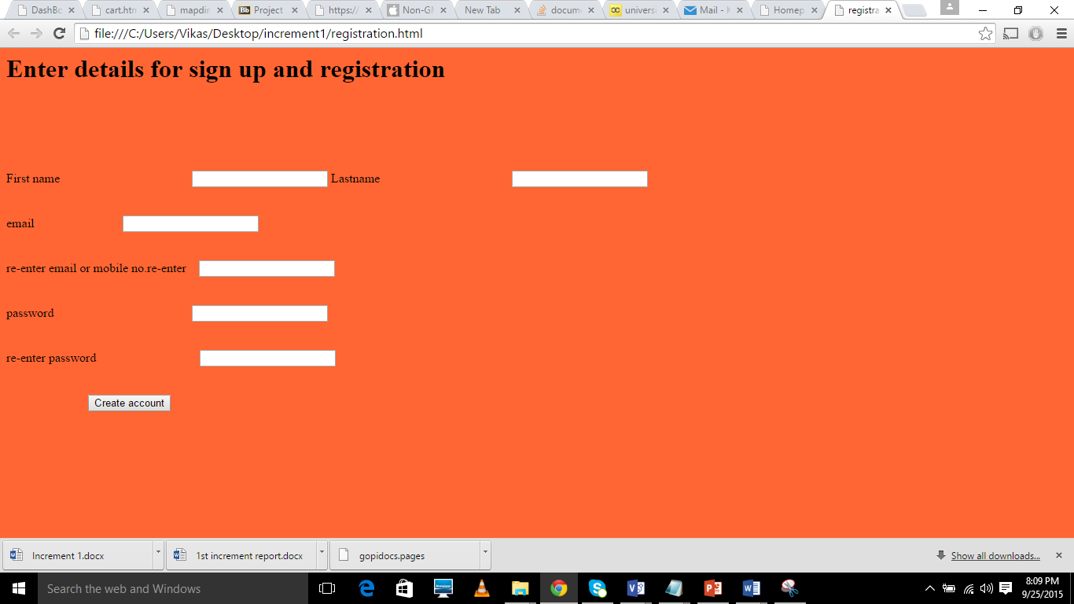

**Login Page**

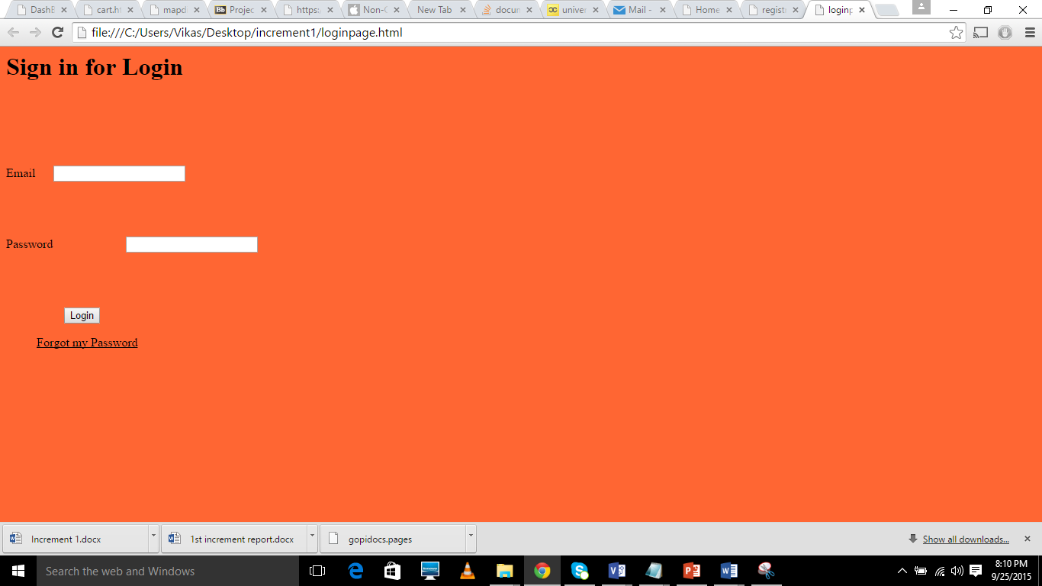

**Dashboard page**

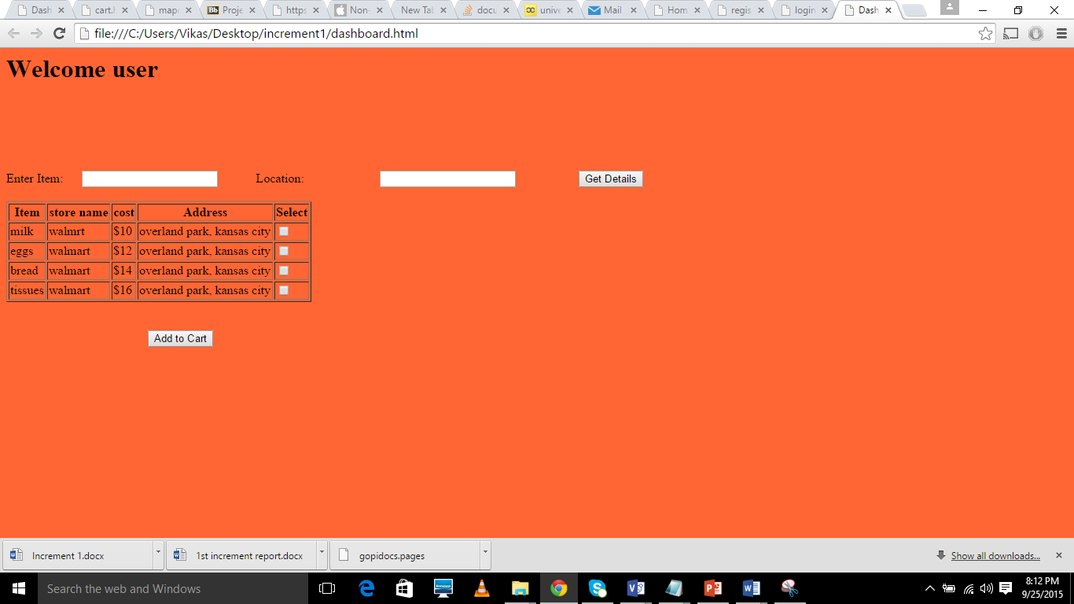

**Cart Page**

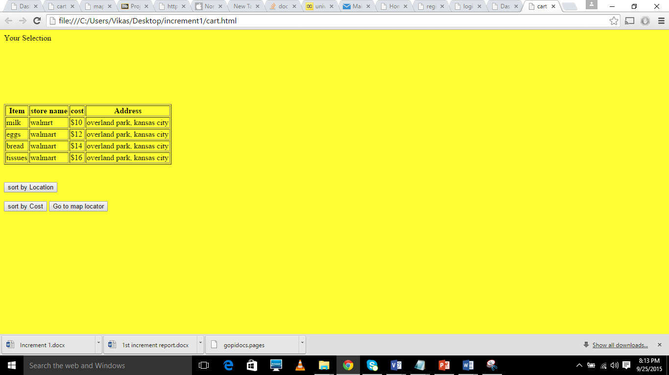

**Map Locator Page**

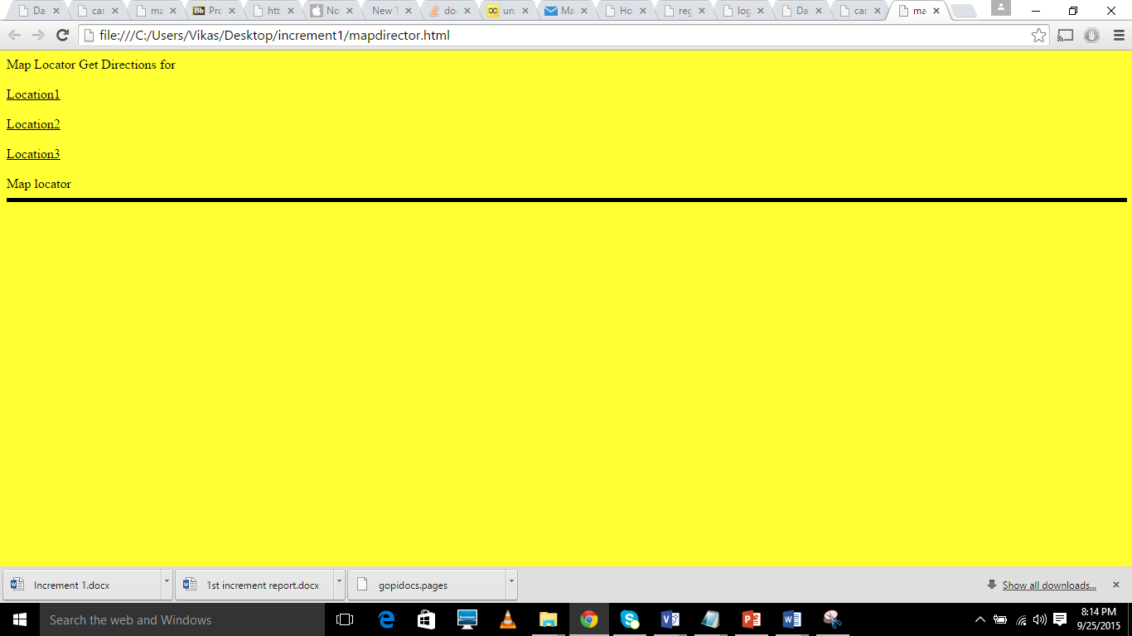

**STORYBOARD**

In this increment

As a system, it must able to validate given login id and password provided by the user and displays message to the user

As a system, it must able to access detail from supermarket API and provide detail to user such as product id, store name, store location, store address, store id.

As a system, it must able to use google API and locate the store on the map that user has selected.

As a system, it must able to display name of user in dashboard by welcoming user with username.

As a user, there must allow to view list of item in particular store and able to select item from the list

**Testing**

**Unit Testing (Manual)**

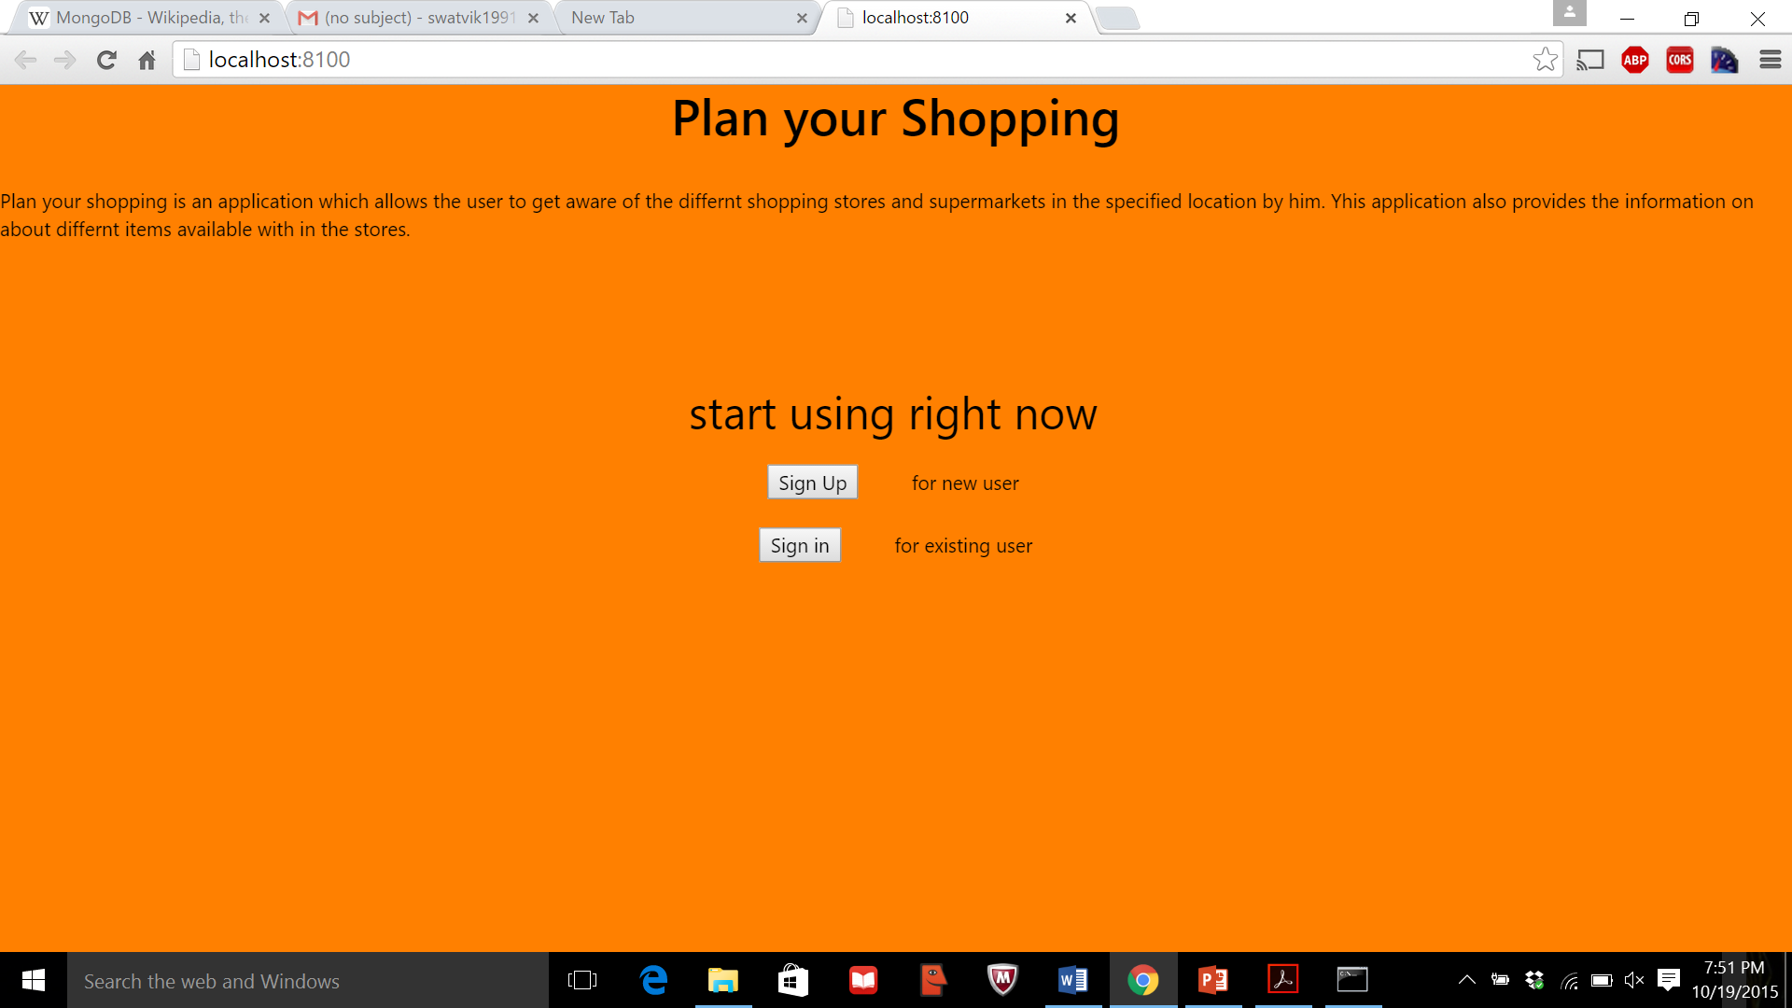

This is the home page of application with two buttons one to sign in and the other to sign up with the website.

**Testing Sign up button**

Expected Output: On clicking the Sign up button it should redirect the user to the Registration Page.

Actual output: On clicking Sign up button the user was redirected to the Registration Page.

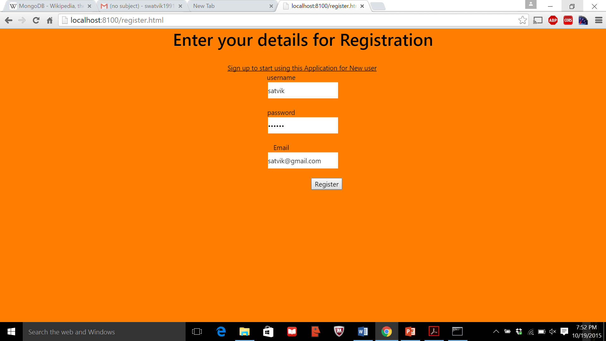

**Testing Sign in button**

Expected Output: On clicking Sign in button it should redirect the user to login Page.

Actual output: On clicking Sign in button the user was redirected to the login Page.

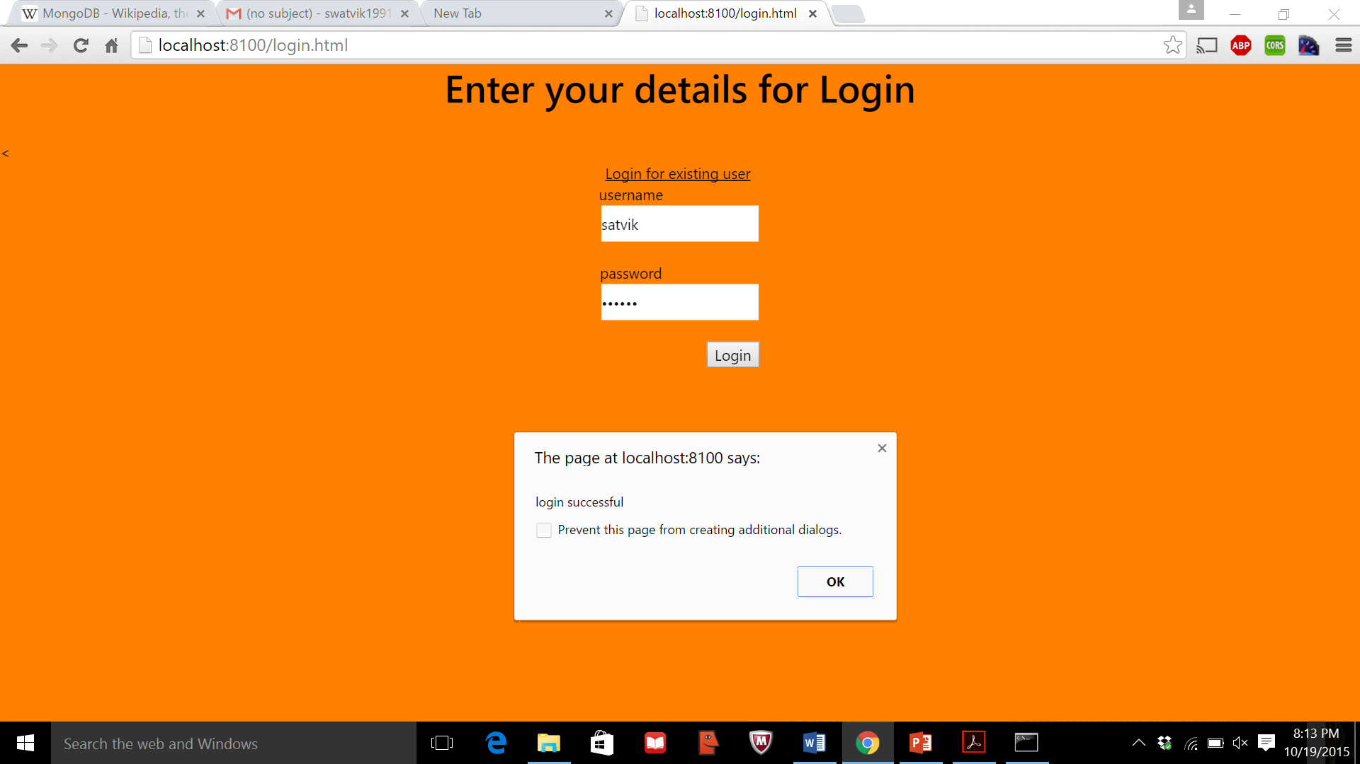

Testing Login page for correct username and password combination



In this login page we have given same username and password which was provide in registration page. It displays login successful for valid data.

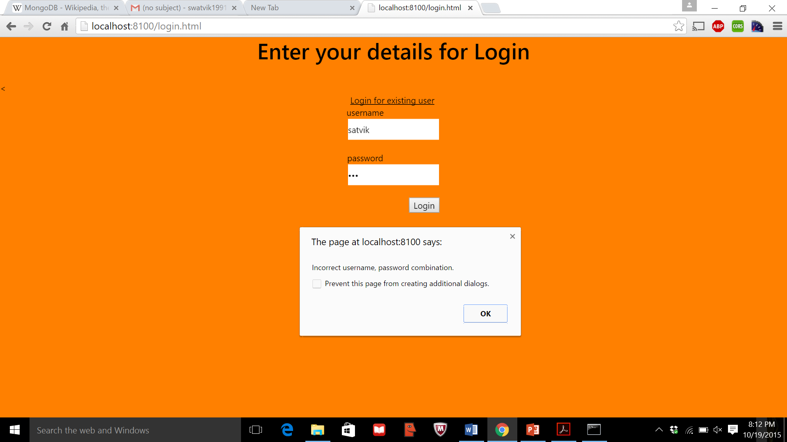

This time we have given invalid password with different length of password then system responding with incorrect message

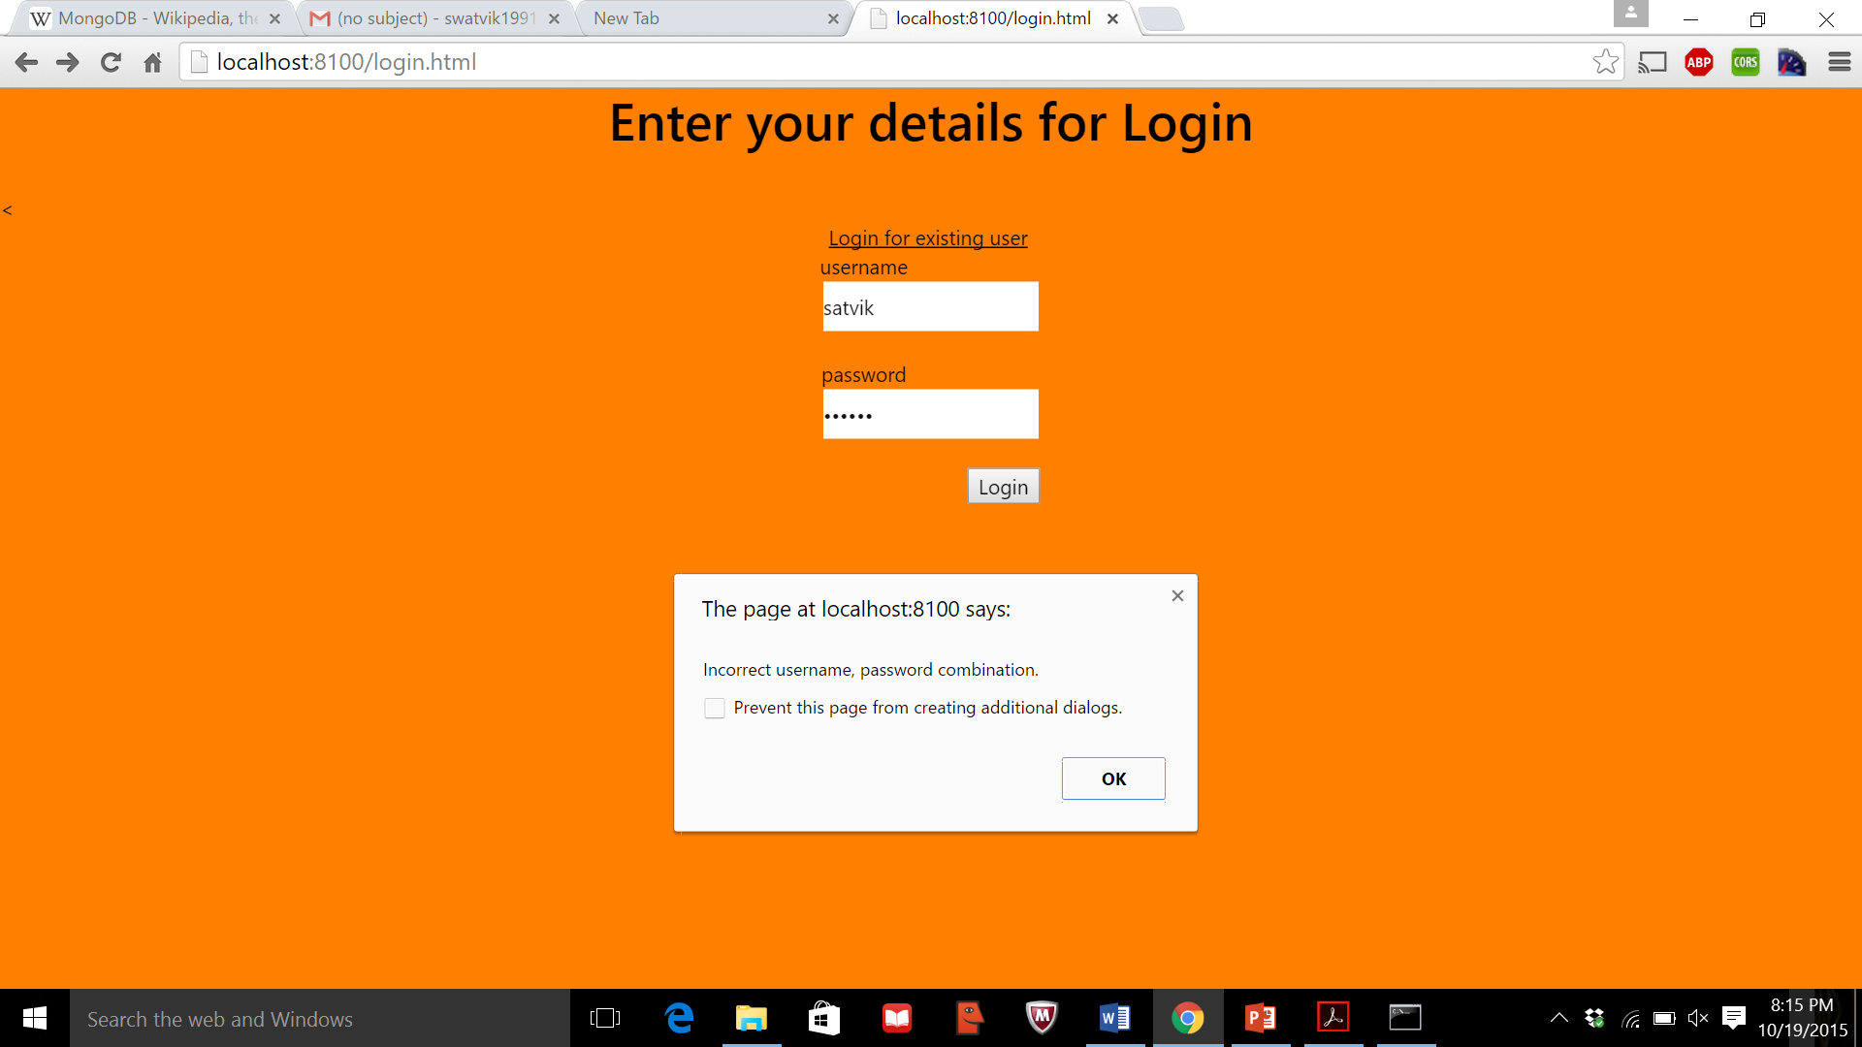

This time we have given password with same length as valid password for username then system displays with incorrect username and password combination message.

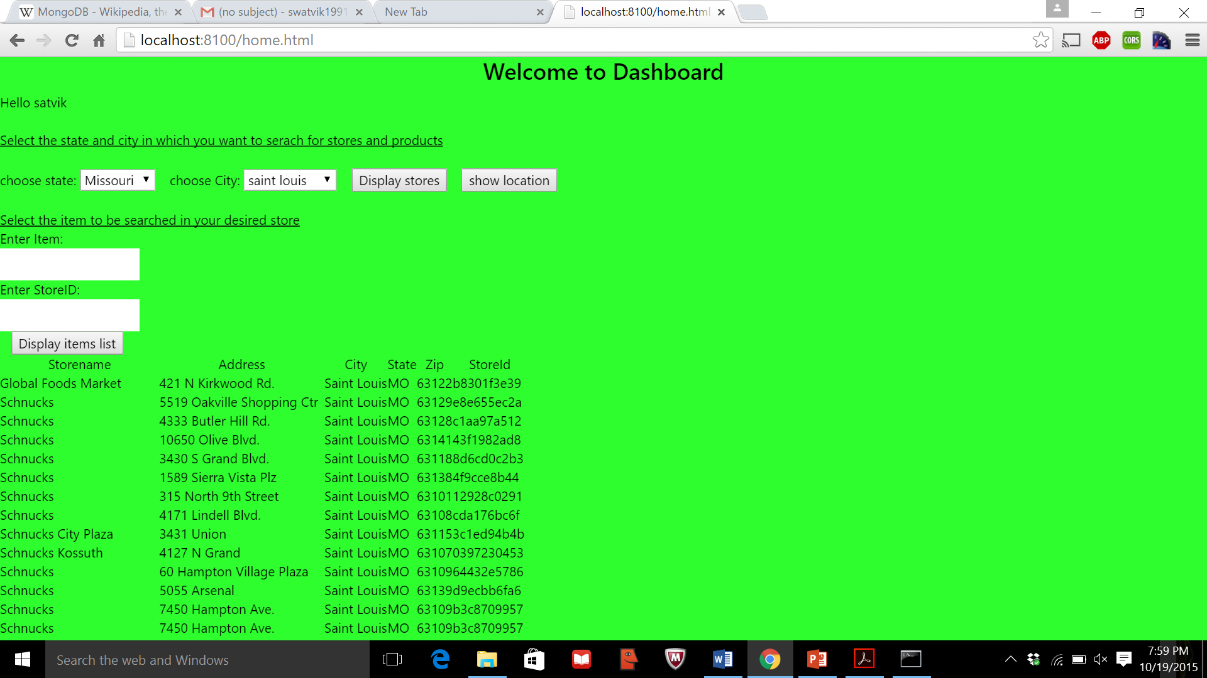

After logging into the system we have the dashboard page of application where we select state and city

On clicking “display stores” button the system displays list of stores located in the given city.

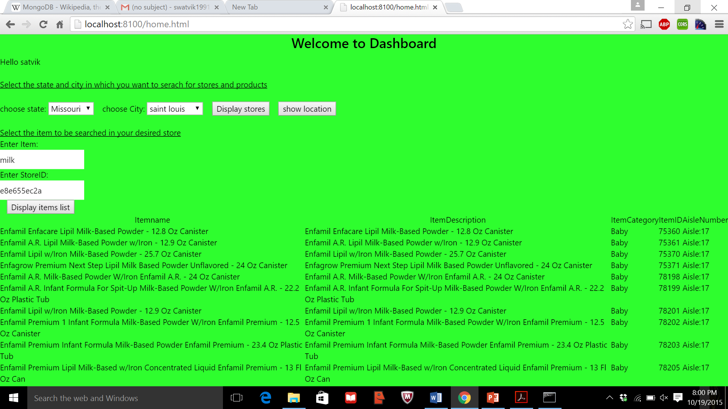

On typing item and stores id in text box from following list then clicking “display item list” it displayed item based on stores and item selected by user. Here we have selected milk and entered stored id in textbox.

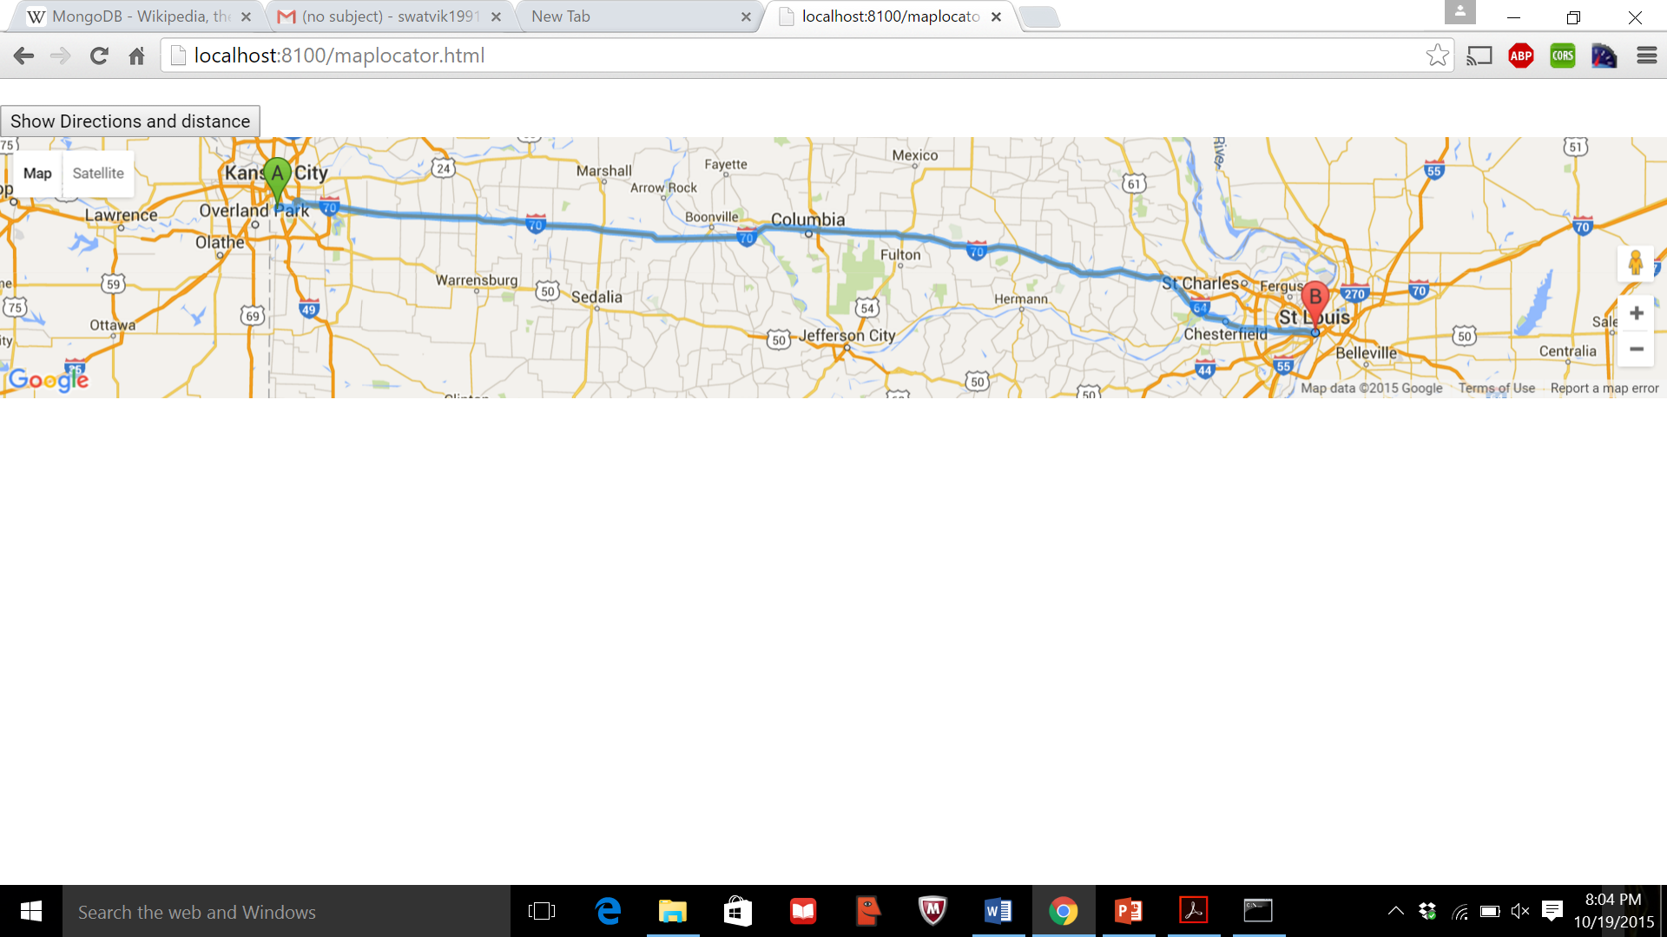

In this increment we only show only direction from current location to selected city further enhancement will be done in coming increment.

**Performance Testing**

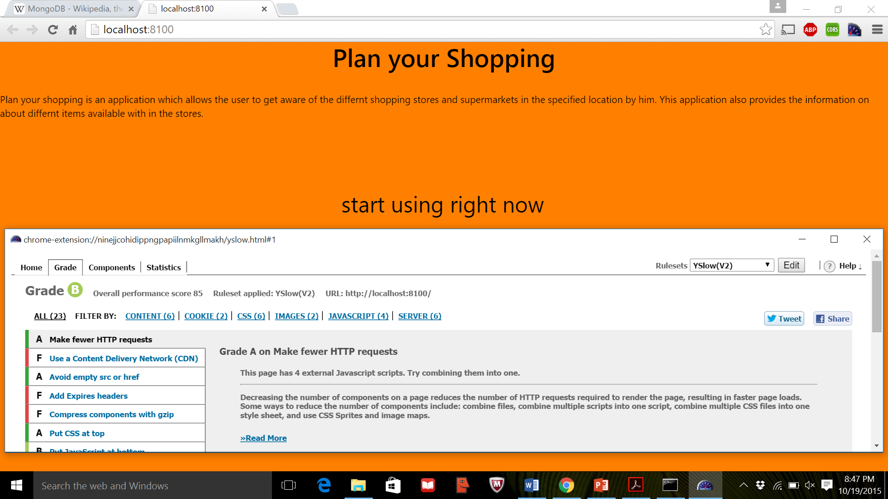

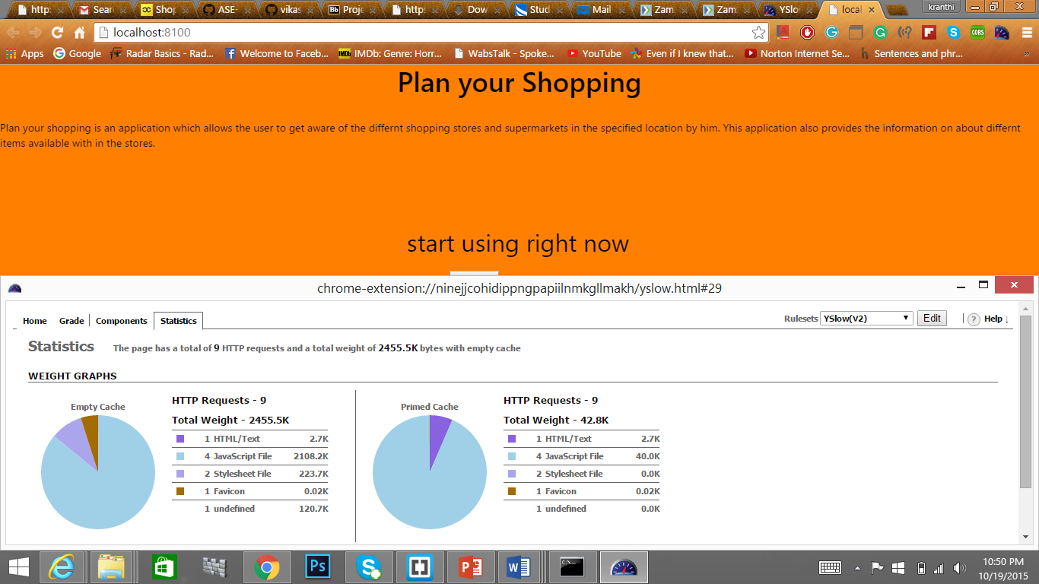

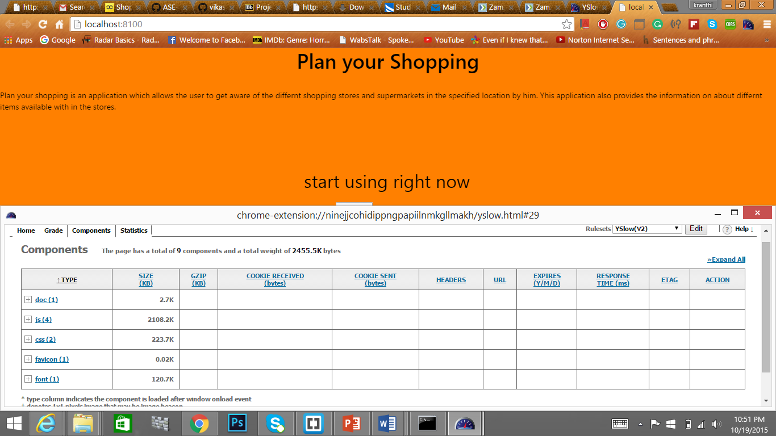

The above screenshots shows the results of performance testing on our website using YSlow.

From the results of the test we have come areas like usage of Content Delivery Network and Expiry Headers where the performance is low and needs improvement. We will fix these issues in the next increment.

**Implementation**

**Server Side Implementation:**

The server side implementation of this application mainly consists of processing of API used in this project.

The APIs used in this project are “Supermarketapi”, “GoogleMaps” API, “MongoDB” API.

The Login and Registration pages use MongoDB API. Registration page uses MongoDB API for storing the details of the user in Mongo Database, and Login Page uses MongoDB API for reading the details of the user.

“Supermarketapi” contains list of the stores along with details of their location. It contains the information regarding all the items in these stores. All these details are stored in the XML format in this API. This provides an easy way to perform search on stores and items by simple entry of location name and item name.

MapLocator page in this application uses the Google Maps API to locate the store selected by the user. It locates the address of the store in Google Maps and also it specifies the distance between the user and the store.

Link for Supermarketapi used in this project:

<http://supermarketapi.com/Default.aspx>

Link for MongoDB Data API used in this project:

https://api.mongolab.com/api/1/databases/vikas2/collections/users?apiKey=HxPILPvmcIj3SyZBMlrPV38t7_BiBKUJ

Link for Google Maps API used in this project:

<https://maps.googleapis.com/maps/api/js?v=3.exp&sensor=true>

**Client Side Implementation:**

Registration page implementation:

Registration page allows the user on his/her to enter his details and sign up for start using this Application. This page reads the details of the user and access the MongoDB API and stores the details of the user in the MongoDB database.

Login Page implementation:

Login Page allows the user on his/her device to login into the Application to start using this Application. This page reads username and password of the user and validates them. If the user has entered the correct combination of username and password then it redirects him to the Home page. Here, validation is performed by comparing the details entered by the user with details existing in the MongoDB database by accessing the MongoDB API.

Home Page implementation:

Home page allows the user to select the State and City in which he want to search for stores. For second increment the state and city option are limited to Missouri state and Saint Louis, Woodhavens cities respectively. This will be updated to all the states and cities in further increments. Once the user selects the required state and city, all the store existing in that city are displayed. Home Page also allows the user to search for a specific item in any of the store displayed in the list. All this is performed by accessing the “Supermarketapi” API and performing search on this API and fetching the required details from the server and displaying it on the client.

MapLocator Page implementation:

Maplocator Page reads the location selected by the user and traces direction from the user current location to the store location and displays the distance to be travelled. MapLocator page does this by accessing the Google Maps API and giving the user specified location as parameters to it.

**Screenshots of Implementation of Application:**

**Index Page:**

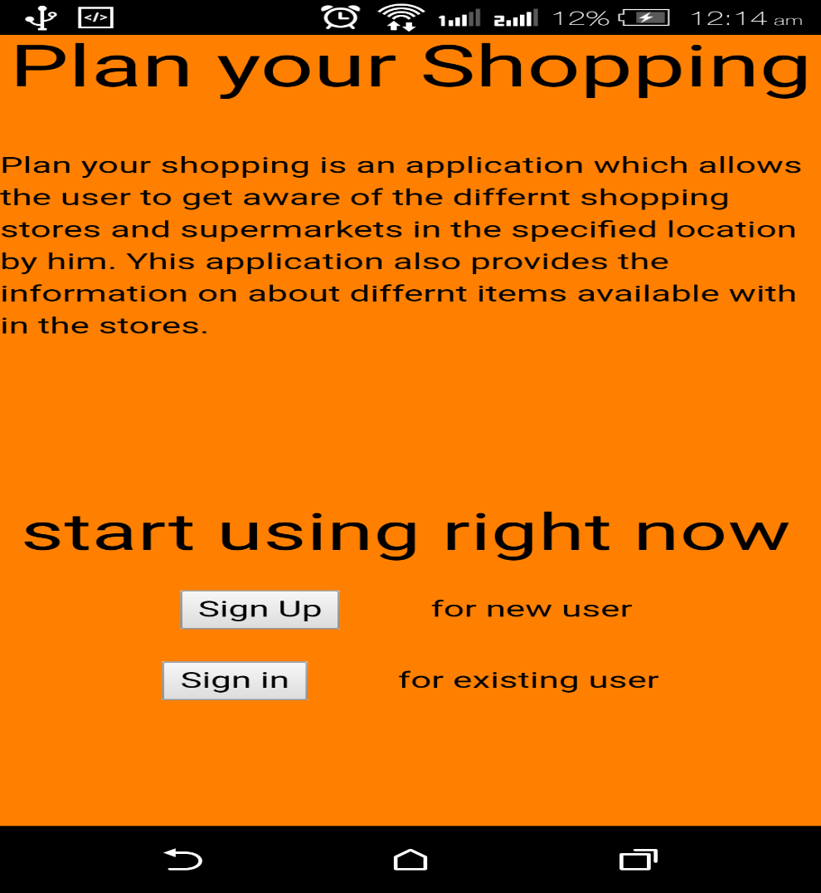

Index Page is the first page of the Application which the user sees. This Page displays the name of the Application and basic information about application. It also contains two button Sign Up and Sign In. On clicking Sign Up user will be navigated to Registration page and on clicking Sign In user will be navigated to Login Page.

**Registration Page:**

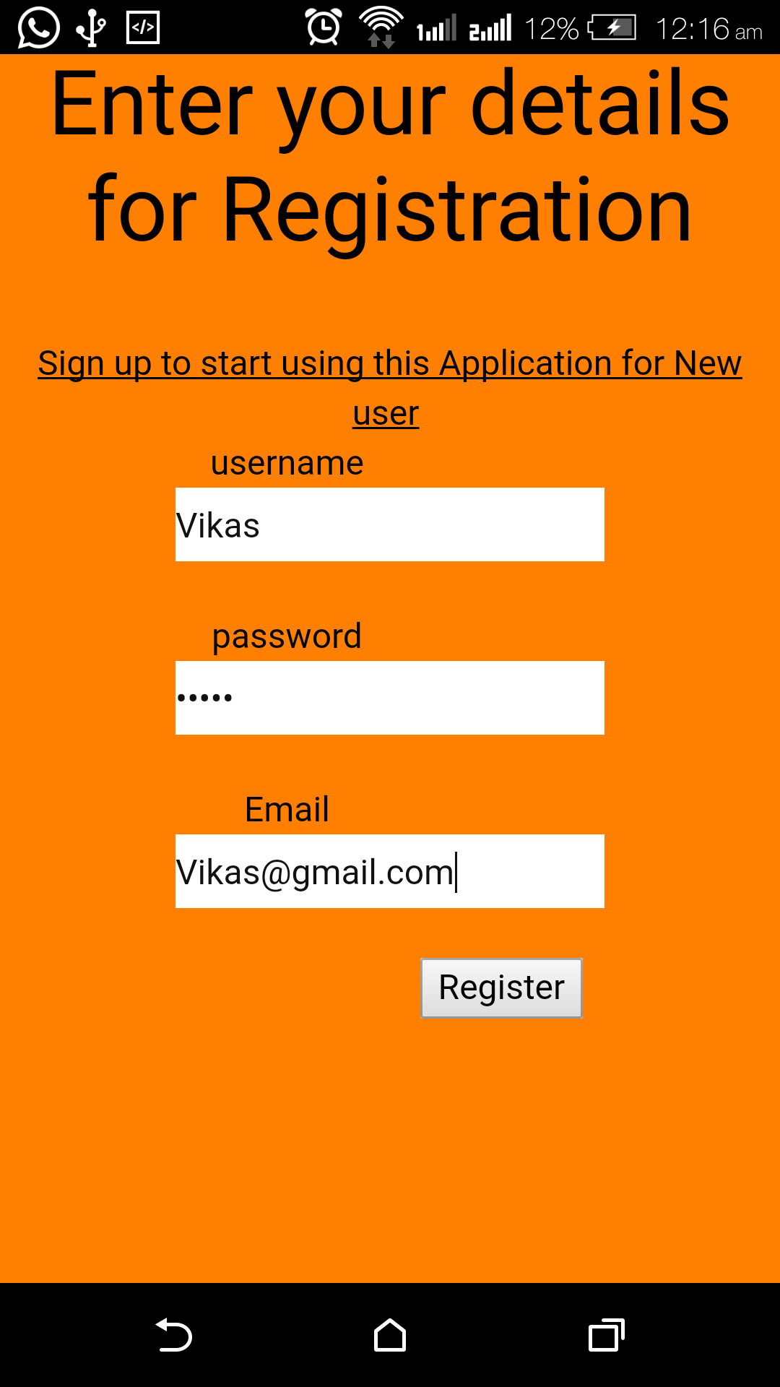

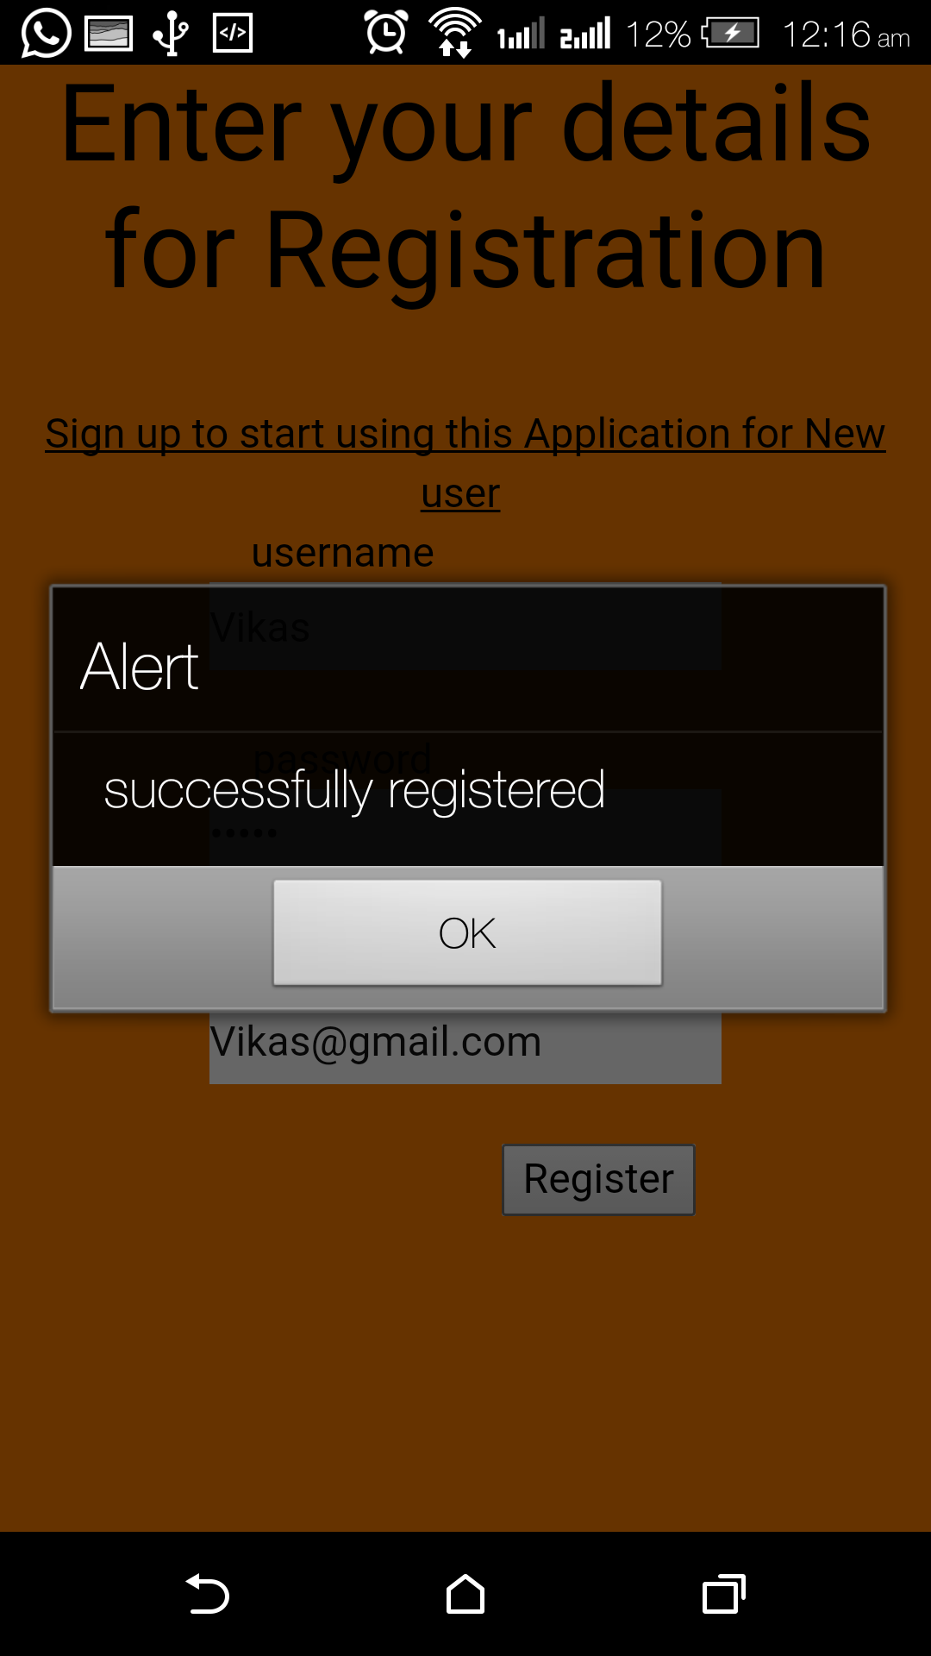

Registration Page contains Text boxes for entering Username, Password and E mail-ID of the user. On clicking Register button the details will be stored into the Database and the user will be provided with acknowledgement of successful registration.

Login Page:

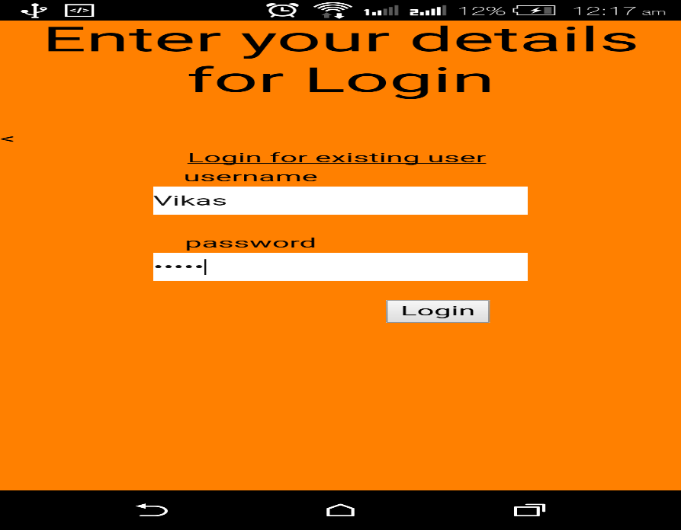

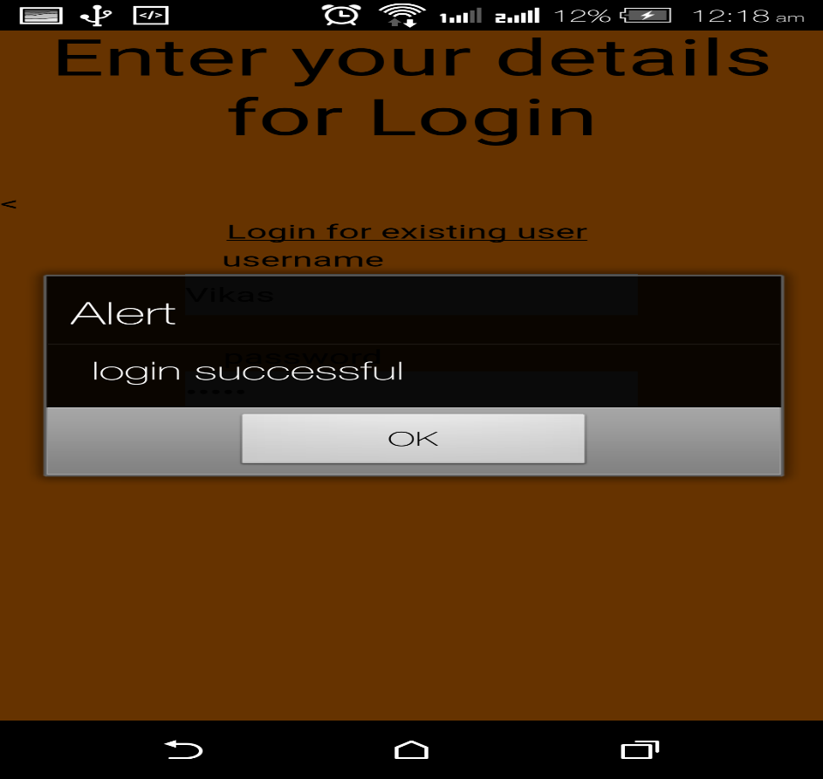

Login Page contains fields for entering Username and Password of the user. On ccliking the Login button the user details are validated and if the details are found to be correct the an alert message that login has been successful is provided and he will be directed to home page.

**Home Page:**

Home Page of the user prompts the user to select state and city in which he want to search for the stores. On clicking Display Stores button the details of the stores in that city are displayed in a tabular format.

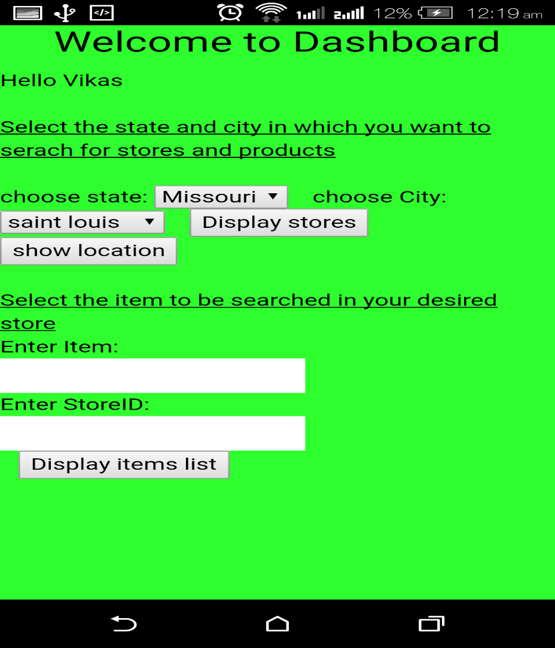

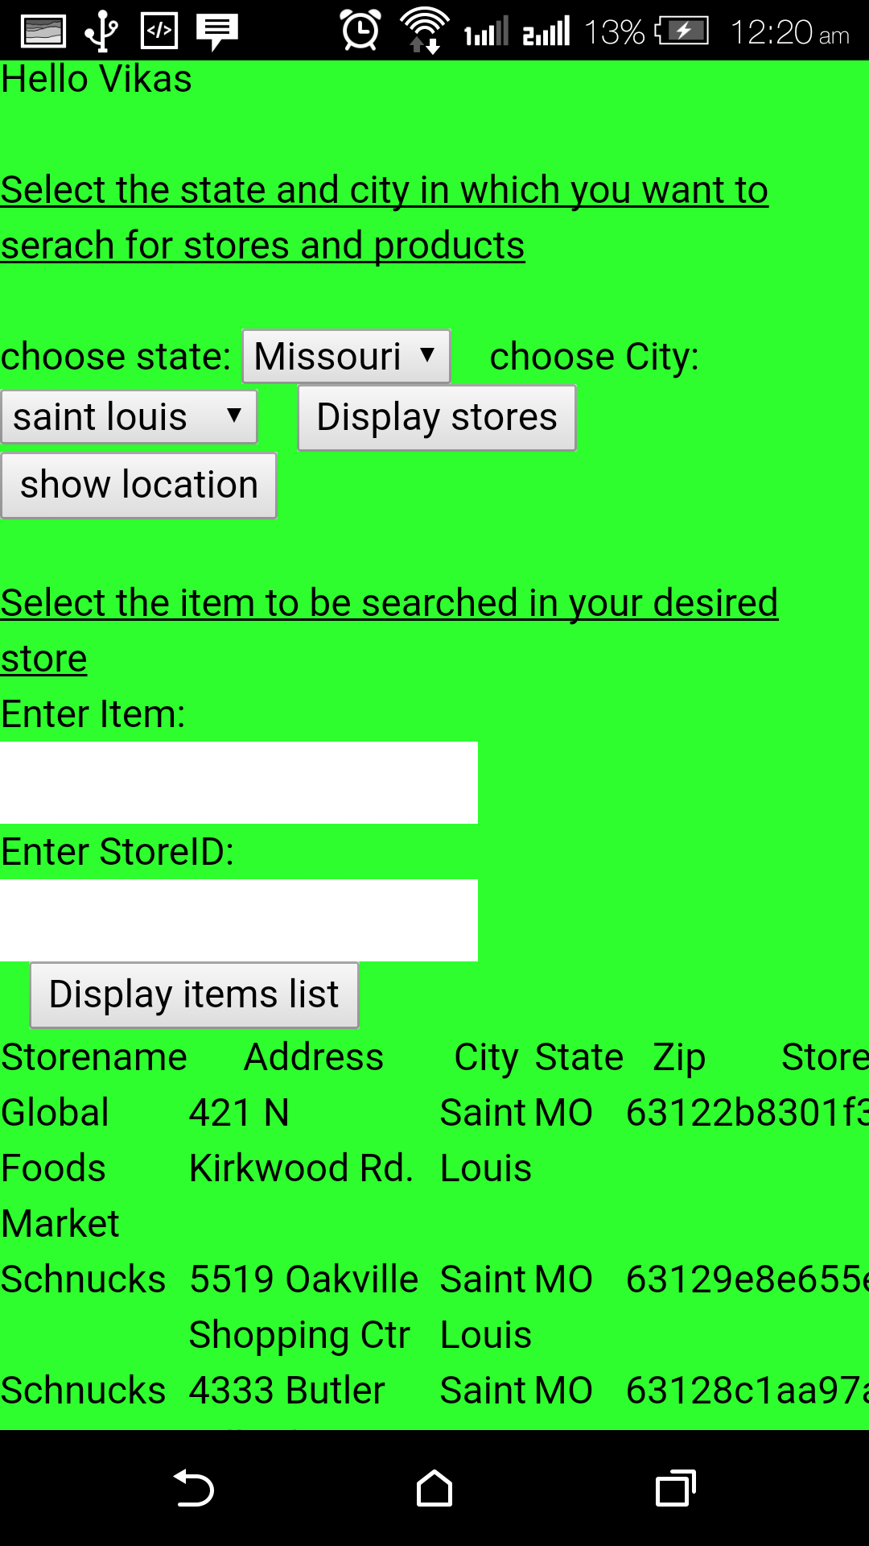

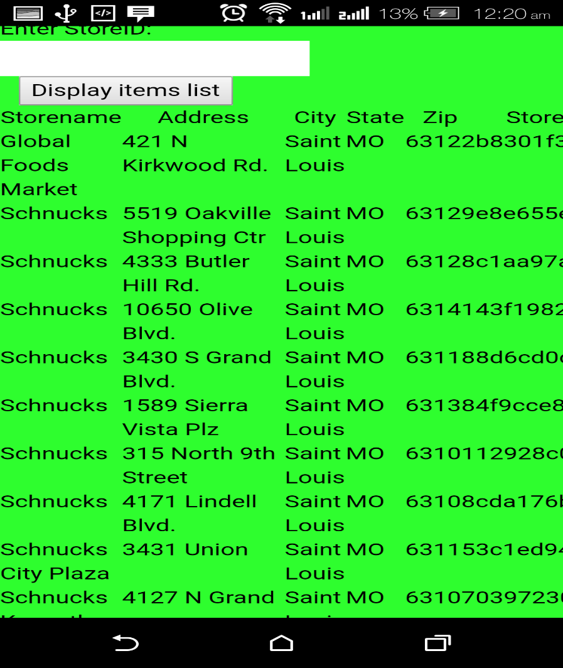

The Home Page also provides the user to search for a specific product with in a required store with in the list displayed. The user need to a keyword pertaining to the product and the storeID to search for that product in the specified Store.

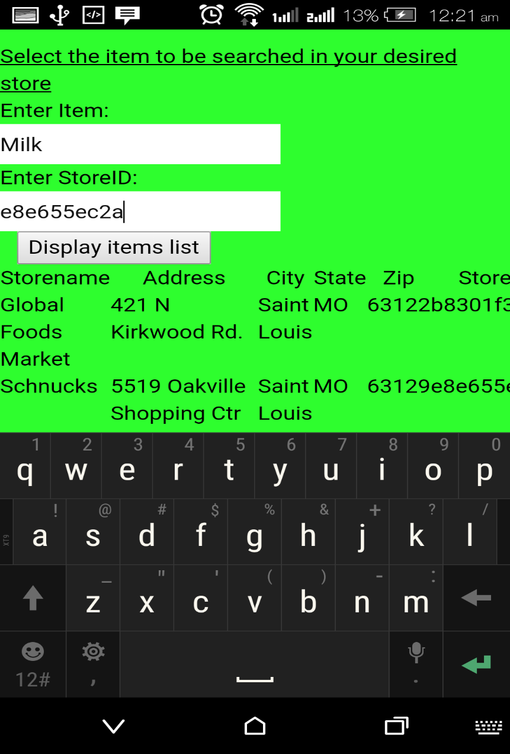

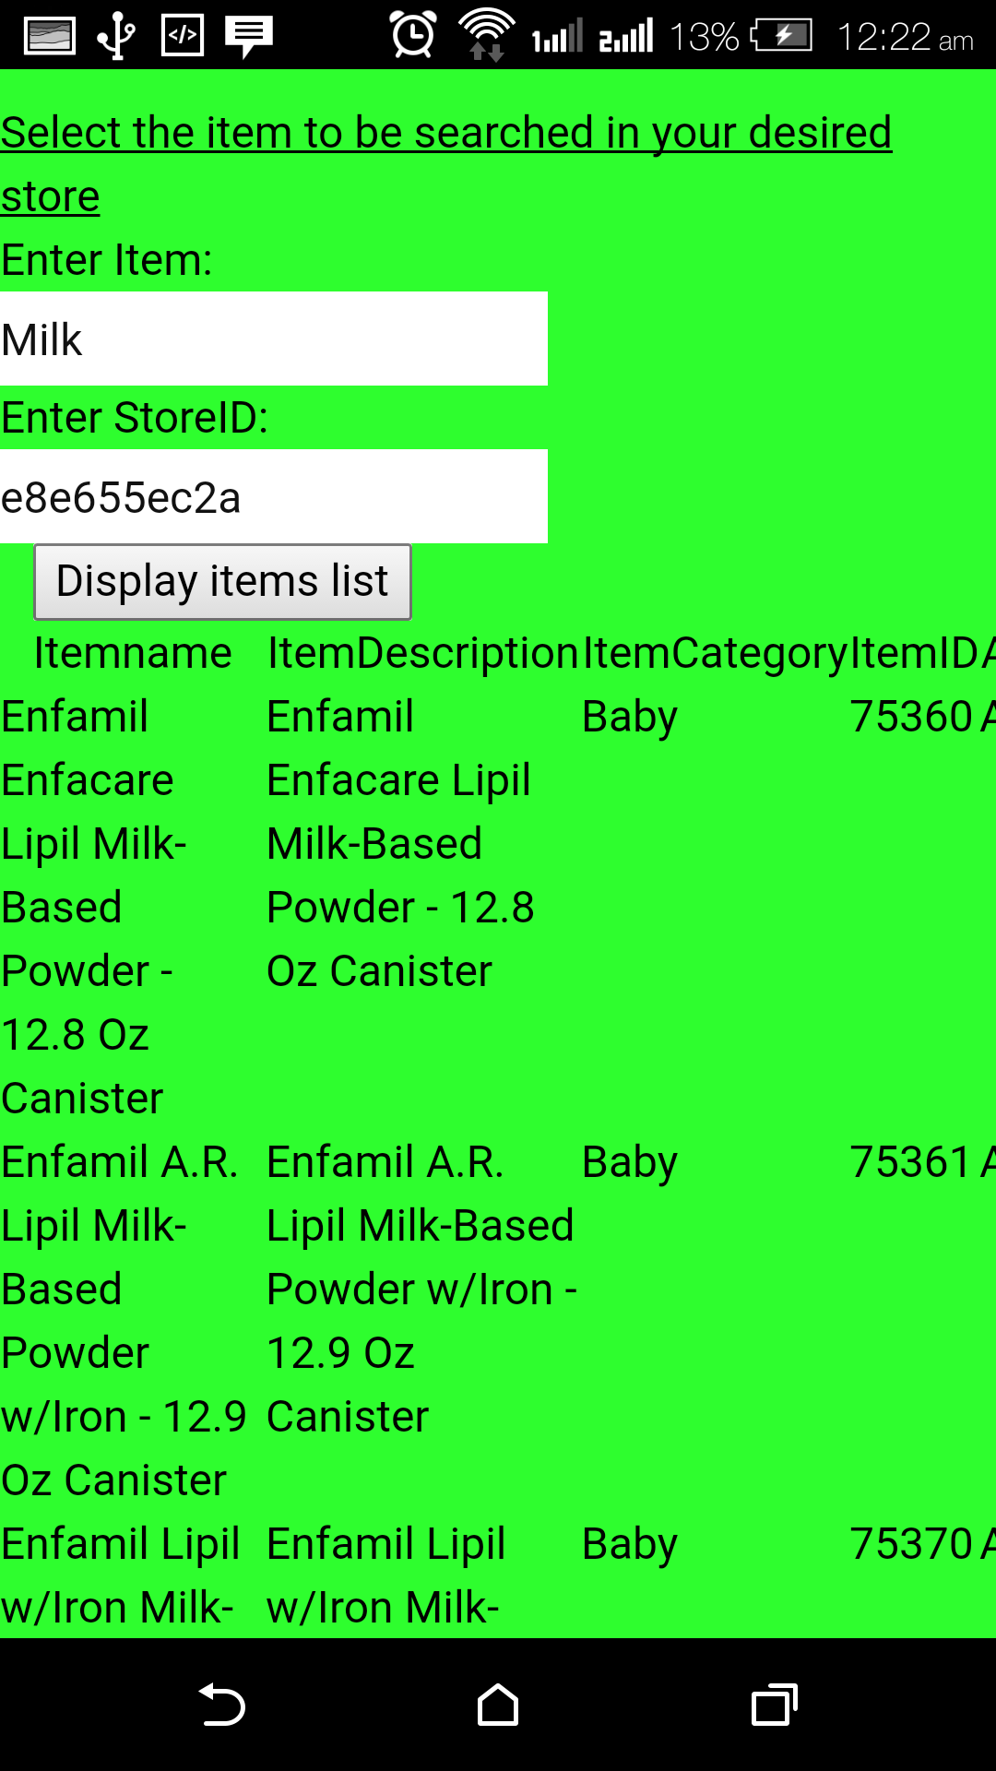

Map Locator Page:

Map Locator Page Shows the directions from the user location to the city specified by the user for store location.

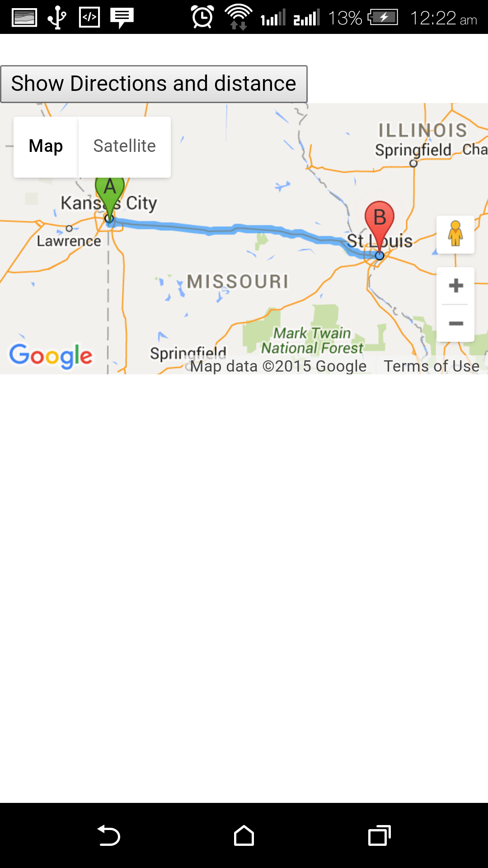

**Project Management**

This Project has been managed using the Kanban tool. This project has been planned to be completed in four increments. The first increment has already been completed.

For the second increment, the tasks to be done were already planned and they were at the Waiting stage at the time of first increment. These tasks are eventually completed and moved to the Done phase.

The tasks designed for the second phase are

* **Development:**

1. Develop Login and Registration pages.
2. Develop Database for storing user details.
3. Develop Dashboard (Home) page.
4. Integrate the Dashboard page with SuperMarket API.

* **Testing:**

1. Test the functionality of Login Pages.
2. Test the functionality of Registration Pages.
3. Test the Dashboard page for displaying of list of stores for the selected city and state.
4. Test the Dashboard page for displaying of list of items available for the specified keyword for item in the specified store.

Initially all these tasks were in the waiting phase at the beginning of second increment.

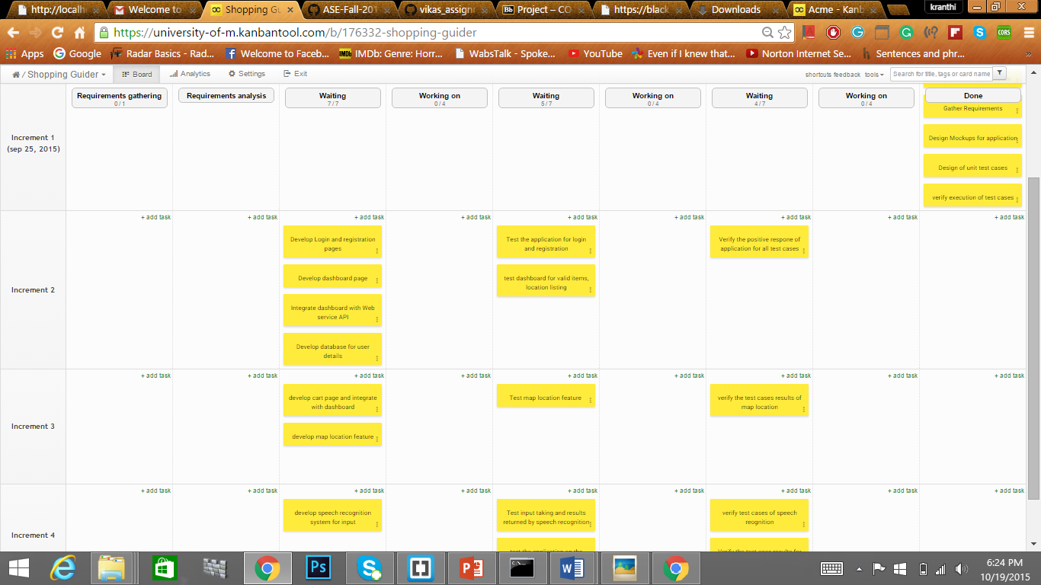

The first task which is carried out was the developing of MongoDB database and getting a DataAPI for accessing it. Then next task was to develop Login and Registration pages

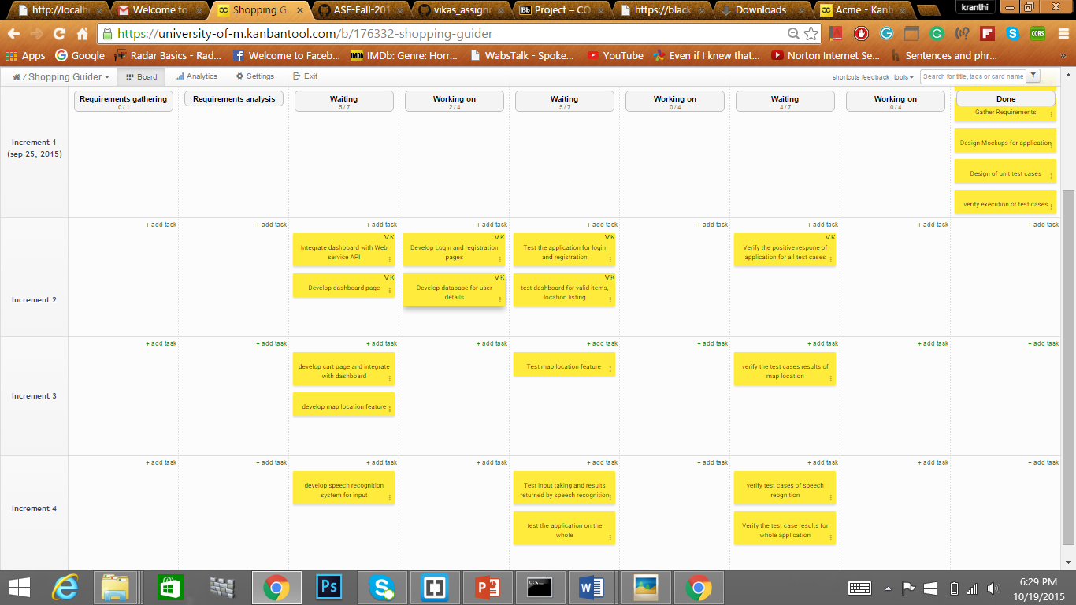

Both these tasks were successfully completed and moved to done phase.

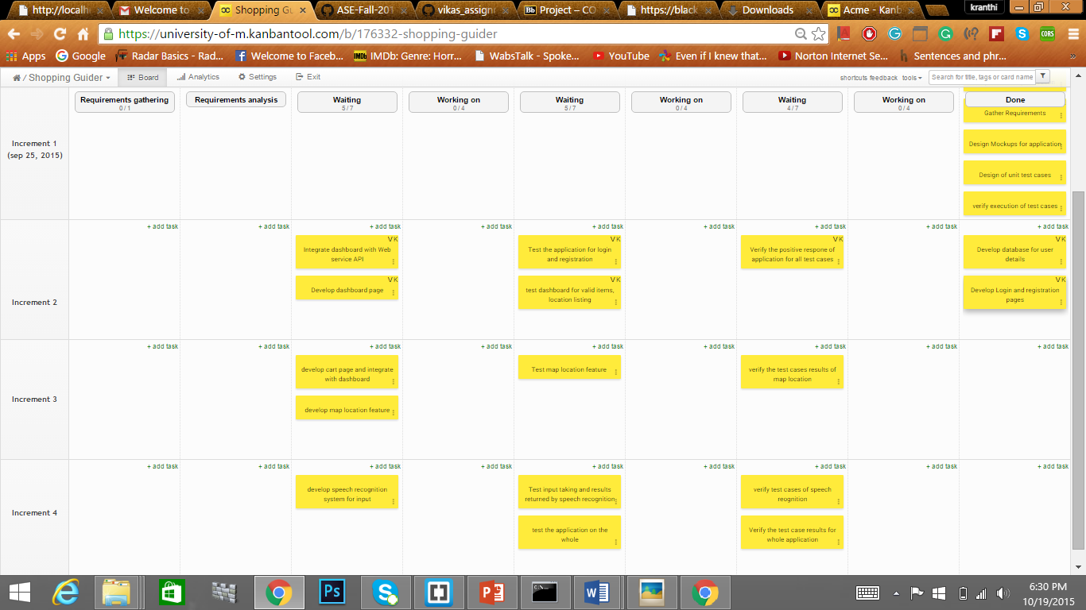

The next tasks were Developing the Dashboard page and integrating the dashboard page with Supermarket API. Both these tasks were worked on simultaneously.

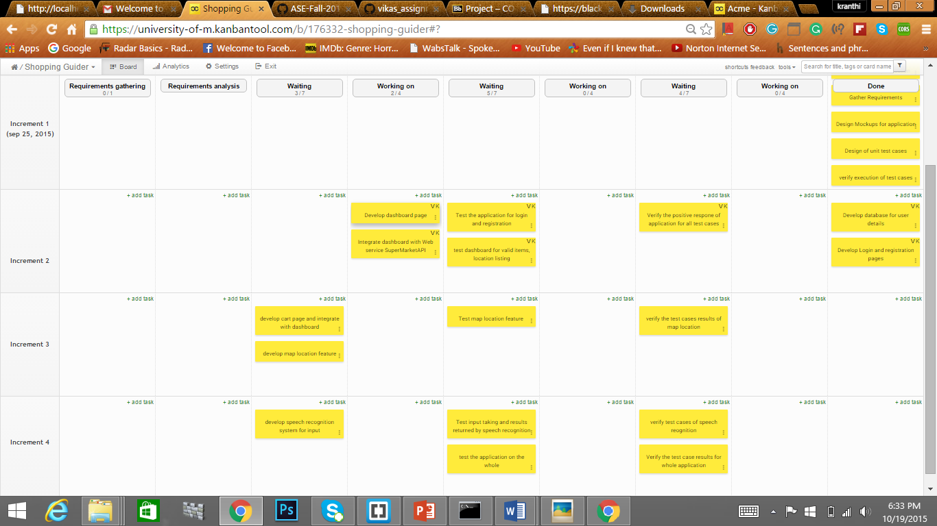

Both these tasks were successfully completed and moved to done phase.

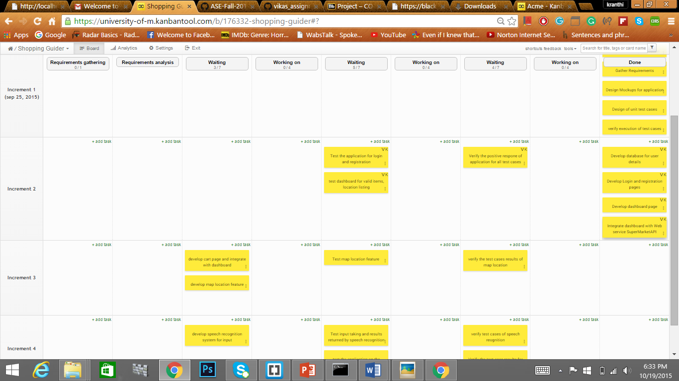

The next tasks were to test the login and Registration pages, test the stores, items list displaying functionality of Dashboard (home page).

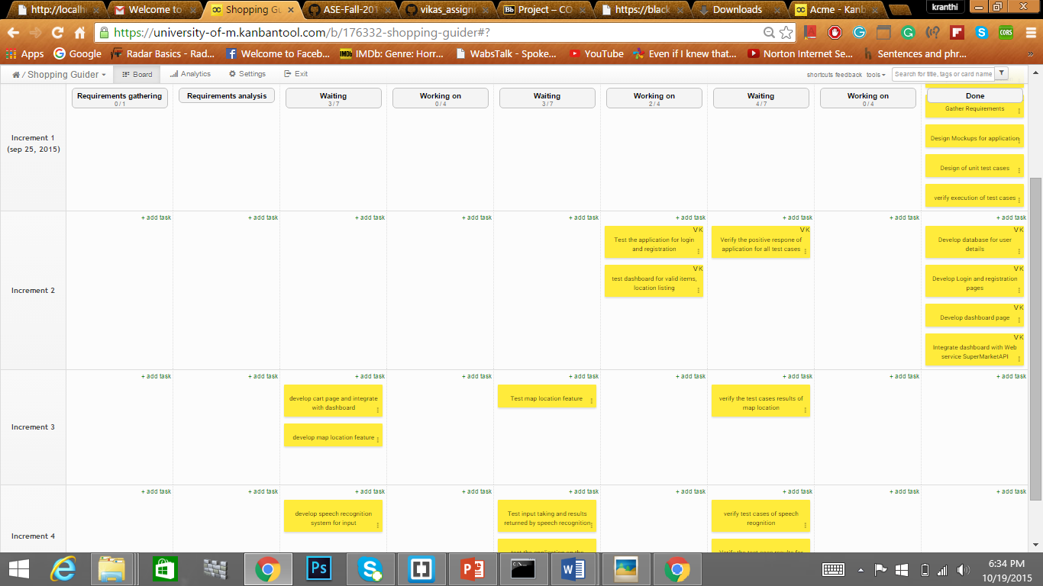

Both the testing tasks were successfully completed and moved to the done phase.

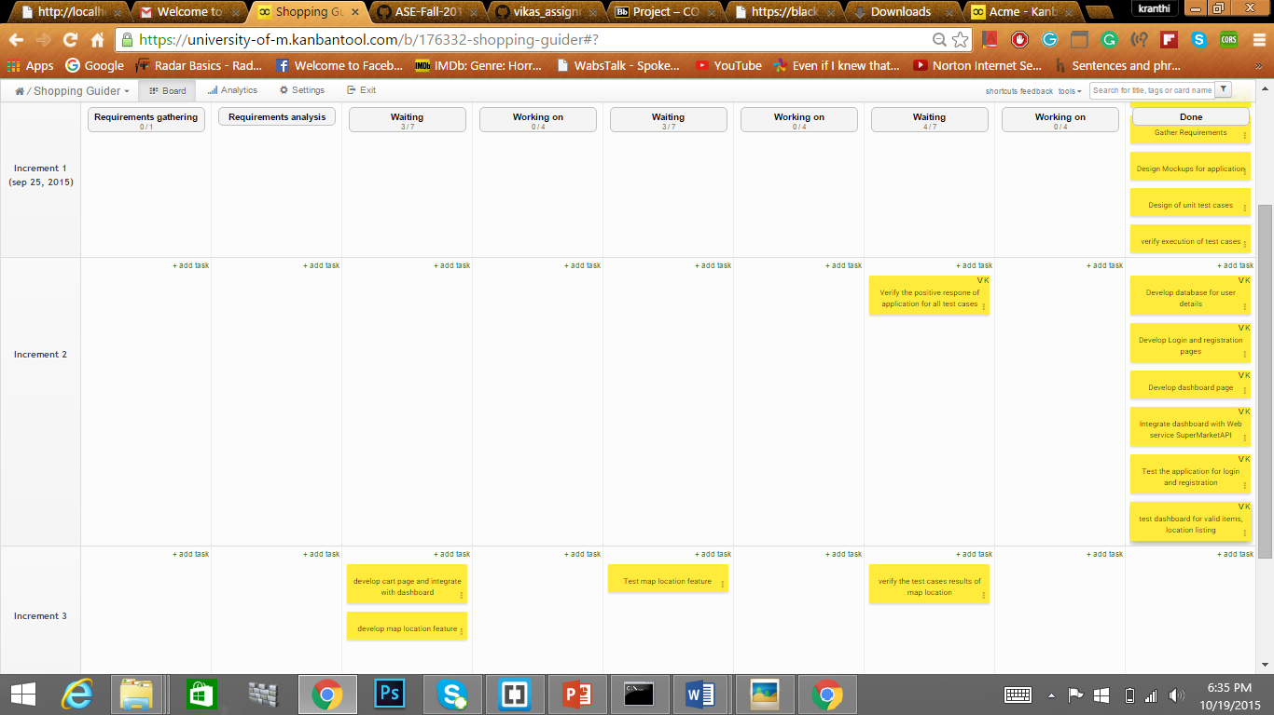

The next task was verifying the test case outputs with the expected outputs in the test case design.

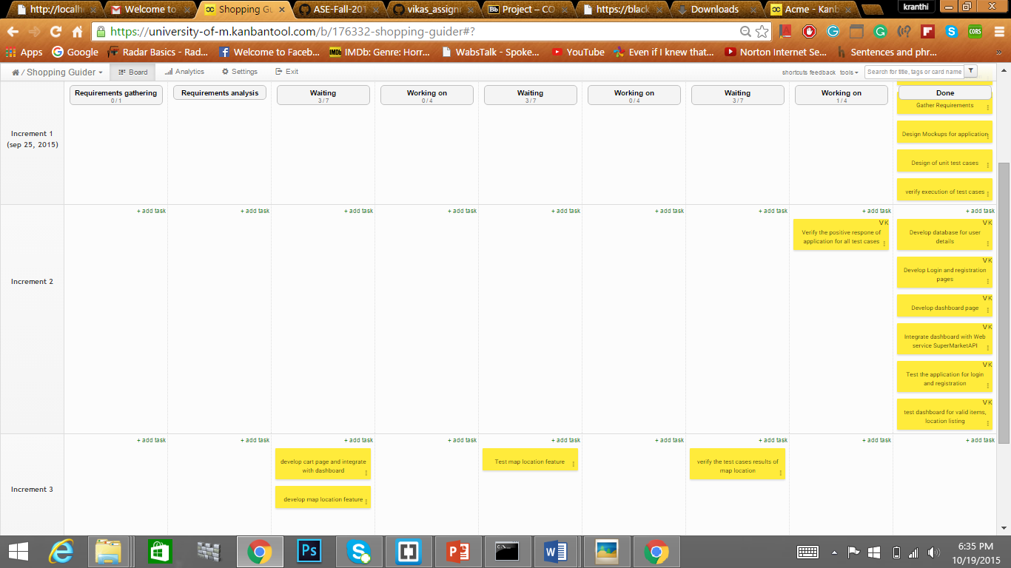

The above task was successfully completed and moved to done phase.

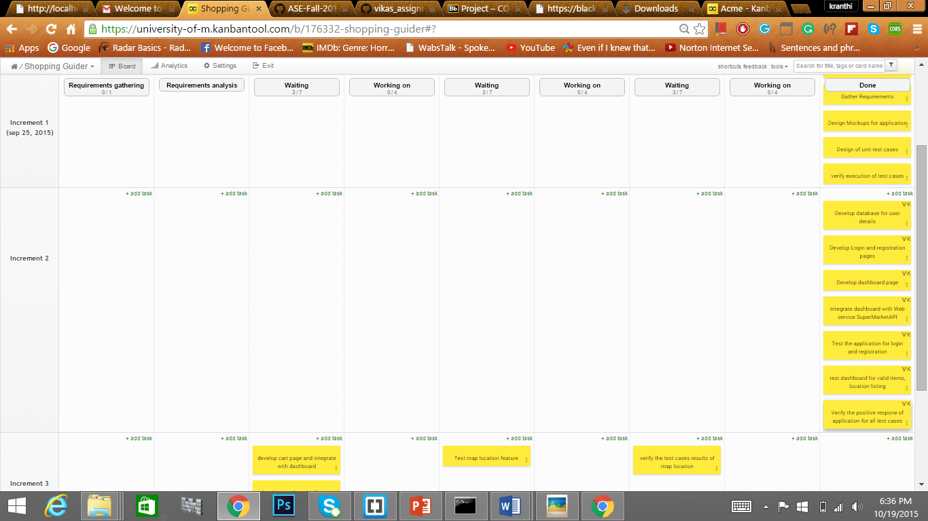

**Work completed:**

**Description:**

* Developed Login and Registration pages and their functionalities.
* Developed Database for storing user details in MondoDB and integrated it with Login and Registration Pages.
* Develop Dashboard (Home page) that displays list of stores and items based on user input.
* Integrated the supermarket API with the Dashboard page.
* Integrated the Google Maps API with Dashboard Page.
* Tested the Login and Registration pages for correct functioning.

**Responsibilities:**

* Vikas kondapalli :

Developing login page by connecting to MongoDB, Developing Dashboard page, Integration and accessing Supermarket API, Google Maps API, testing, documentation.

* Gopi Krishna Bodapati:

Developing registration page, developing MongoDB database and access it using data API , testing, documentation.

* Swatvik Gunamaneni:

Developing map locator page using Google Maps API, testing, documentation.

**Time taken:**

* Developing login page, Registration page: 90 hours
* Developing Dashboard page and integrating it with web service APIs: 110 hours
* Testing : 20 hours
* Documentation: 20 hours

**Contributions:**

* Vikas kondapalli : 33.33%
* Gopi Krishna Bodapati: 33.33%
* Swatvik Gunamaneni: 33.33%

**Work to be completed:**

**Description:**

* Developing a cart page and integrating it with Dashboard page.
* Improvising the Map Location page with desired store location to be more specific on Map.
* Improvising the Dashboard page for letting the user perform search on stores in all the States in the USA as the current page only deals with Missouri state.
* Testing the cart page.
* Testing the Map location page.
* Developing a speech recognition feature for letting the user enter his input through his voice.

**Responsibilities:**

* Vikas kondapalli :

Improvising the Dashboard page for letting the user perform search on stores in all the States in the USA, testing, documentation.

* Gopi Krishna Bodapati:

Developing a cart page and integrating it with Dashboard page, testing, documentation.

* Swatvik Gunamaneni:

Improvising the Map Location page with desired store location to be more specific on Map, testing, documentation.

Time to be taken:

* Improvising Dashboard page: 60 hours
* Developing cart page: 110 hours
* Improvising the Map Location page: 60 hours
* Testing: 20 hours
* Documentation: 20 hours

**Link for Kanban tool (project management tool):**

<https://university-of-m.kanbantool.com/b/176332-shopping-guider#>?

Username and password are required for accessing it.

**Bibilography**

Link for Supermarketapi used in this project:

<http://supermarketapi.com/Default.aspx>